**Experiment 1.1**

**Student Name: Gaurav Kumar                                     UID: 22MCC20177**

**Branch: CC-DEVOPS                                                    Section/Group : 1/B**

**Semester: 1                                                                    Date of Performance: 01/Oct/2022**

**Subject Name : Python Programming                         Subject Code: 22CAH645**

1. **Task to be done:**

**Practical 1: WRITE A PROGRAM TO PRINT TWIN PRIMES LESS THAN 1000. IF TWO CONSECUTIVE ODD NUMBERS ARE BOTH PRIME THEN THEY ARE KNOWN AS TWIN PRIMES.**

1. **Steps for experiment/practical:**

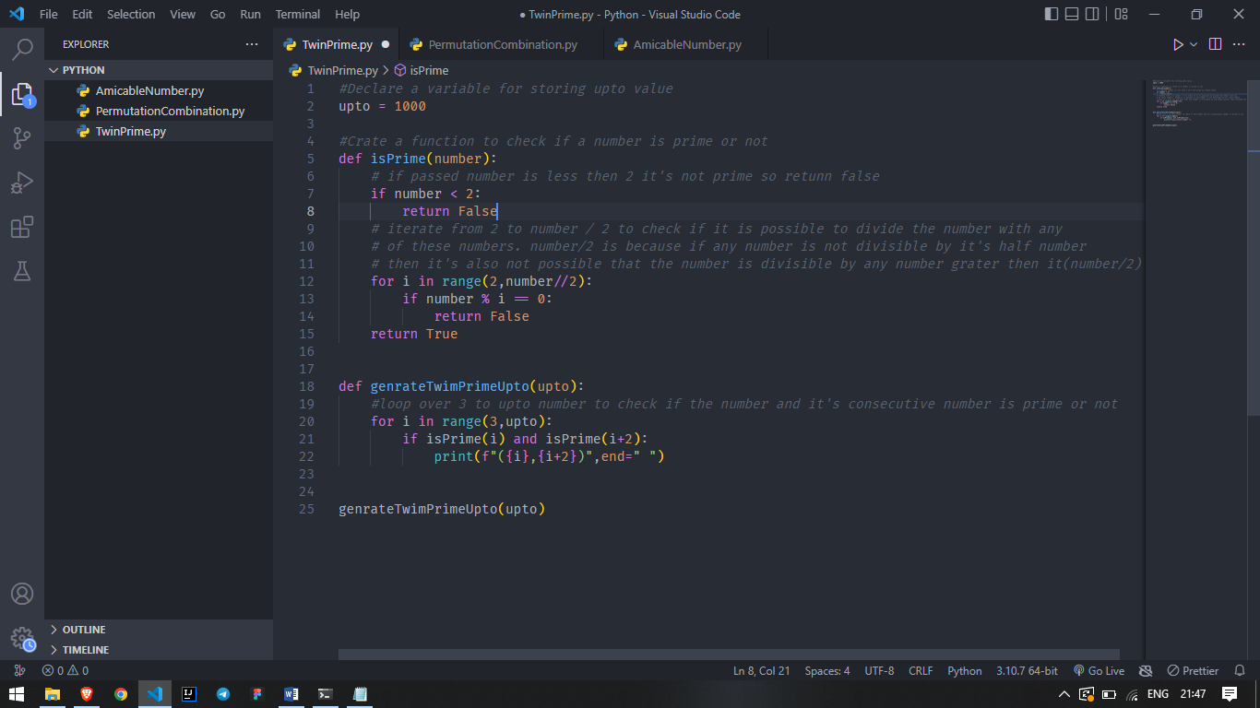

1. **Output (screenshots)**



**4) Learning outcomes (What I have learnt): Times new roman 12 size**

**1. Learn what is twin prime numbers.**

**2. Learn for loop and if else statements**

**3. Learn how to code for to check if a number is prime or not.**

1. **Task to be done:**

**PRACTICAL 2: WRITE A PROGRAM TO IMPLEMENT THESE FORMULAE OF PERMUTATIONS AND COMBINATIONS. NUMBER OF PERMUTATIONS OF N OBJECTS TAKEN R AT A TIME: P (N, R) = N! / (N-R)! NUMBER OF COMBINATIONS OF N OBJECTS TAKEN R AT A TIME IS: C (N, R) = N! / (R!*(N-R)!)**

1. **Steps for experiment/practical: copy and paste your code here/screenshots**

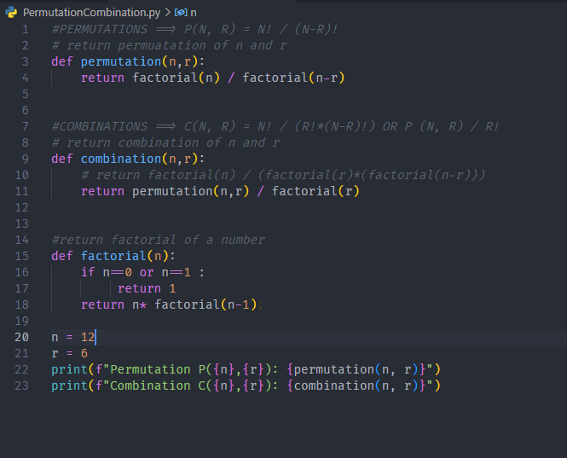

1. **Output (screenshots)**



1. **Learning outcomes (What I have learnt): Times new roman 12 size**

**1. Learn what is permutation and combination is and how to calculate .**

**2. Learn factorial number and code for it**

**3. Learn how calculate factorial recusively.d**

**Evaluation Grid:**

|  |  |  |  |
| --- | --- | --- | --- |
| Sr. No. | Parameters | Marks Obtained | Maximum Marks |
| 1. | Demonstration and Performance  (Quiz) |  | 22 |
| 2. | Worksheet |  | 8 |